Orofacial pain.org.uk
Patient Leaflet for BBurning mouth syndrome
October 2020
Burning mouth syndrome (BMS) is a non-inherited, non-infectious chronic condition characterised by a burning intra-oral sensation.
This sensation can affect the tongue, gums, lips and buccal mucosae either individually or collectively. The tongue is the most commonly affected site and BMS is also known as burning tongue syndrome, oral dysaesthesia, glossodynia and glossopyrosis.
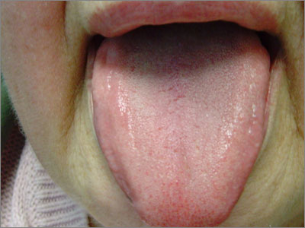
BMS is more common in women. One study suggested approximately one in three women have symptoms of BMS after the menopause. The condition appears to be much less common in men.
It has been reported that approximately two in 100 men and five in 100 younger women had symptoms of BMS.
BMS may be caused by:
- Psychological factors - stress, anxiety, depression, fear of getting cancer;
- Haematological deficiencies - iron, folate, B12, zinc;
- Oral conditions - candida- related infections, lichen planus, geographic tongue;
- Xerostomia - Sjogren's syndrome, diuretics, post-radiotherapy, diabetes;
- Menopause;
- Endocrine disorders - diabetes, thyroid conditions, Cushing's synrome
- Allergy-type reactions - foods (e.g. tomatoes, cinnamon), flavourings
- Gastro-oesophageal reflux disorder.
Lifestyle treatments
- Smoking cessation advice - smoking can exacerbate the symptoms of BMS.
- Avoid spicy foods, especially during peak sore times.
- Avoid acidic foods - tomatoes, vinegar, citric fruits and alcohol, especially during peak sore times.
- Mint and cinnamon, found in certain brands of chewing gum and toothpaste, should be avoided.
- Reduce stress levels
- Food supplements - alpha lipoic acid may protect the nervous system.³⁻⁵
In most patients, no organic cause can be established. This is often termed primary BMS. The tongue usually appears normal (see figure) and there may be a psychogenic basis, often a monosymptomatic hypochondriasis.
A common finding with primary BMS patients is anxiety associated with the worry that he or she may have cancer.
If the burning sensation is caused by factors such as infection, haematological deficiencies, endocrine disorders, and so on, this is often termed secondary BMS.
Clinical features and diagnosis
The main symptom of BMS is a hot/scalded sore sensation. Patients also describe 'tingling'. Other symptoms may include a degree of xerostomia and alteration in taste sensation.
BMS may affect any part of the oral cavity, although most cases seem to involve the tongue.
Often the soreness progressively worsens throughout the day.
Equally, patients have reported random patterns of soreness, which can typically involve whole days of soreness followed by 'pain free' days.
Diagnosis of BMS is usually made on the basis of the history given by the patient. A typical picture would involve a several month history of soreness on most days.
Investigations include:
- Mouth swab - candida +/- bacterial infections
- Haematinics - FBC, U&Es, LFT, iron, folate, B12, zinc
- Social history - evidence of stress, anxiety, depression.
Treatment
Treatment can be difficult as often there is no organic cause. It is important to treat any underlying conditions that may have been noted from blood results or other investigations.
Primary BMS can be challenging to treat and the patient should be warned that treatment may involve several different methods before an improvement is seen.
An important aspect of BMS is to reassure the patient that they do not have cancer. For patients who have cancerophobia or are very anxious about the condition, reassurance is a vital part of the overall treatment plan.
Primary BMS treatment can be divided into lifestyle and drug treatments. Patients with BMS usually benefit from reassurance and a combination of one or more of the treatments mentioned above (see box).
Non-drug treatment is always useful and dealing with any underlying systemic conditions is vital.
Referral to the local oral surgery/oral medicine unit may be necessary for patients who continue to have symptoms not responsive to the treatments outlined above.

