Impact of Migraine and Fibromyalgia on Temporomandibular Disorder: Findings on Pain, Psychological Factors and Quality of Life

Abstract
Background: Temporomandibular disorders (TMD) often coexists with other painful conditions, leading to increased pain intensity and psychological impairment. This study specifically aimed to assess the impact of migraine (MG) and fibromyalgia (FM) on TMD patients, with a focus on pain, anxiety, depression, and quality of life (QoL). Additionally, we investigate the association between the number of comorbidities (sum of TMD, MG and FM) and the aforementioned variables to better understand their interplay.
Methods: We conducted a retrospective data collection, from January 2016 to December 2022. The analysis involved 409 adult TMD patients treated at the Orofacial Pain Clinic, Dental Institute, King's College Hospital. Patients were categorised into four groups: those without comorbidity (TMD- only) and patients with TMD accompanied by MG and/or FM (TMD MG, TMD FM and TMD MG FM groups). Mean comparisons were conducted among the four groups. Linear regression was used to analyze the associations between each outcome variables.
Result: Most of study population were women (79%) with a mean age of 44.43 years. TMD MG patients reported longer pain duration, higher scores for current, most severe, and average pain, and greater pain interference compared with TMD only patients. Similarly, TMD FM patients had higher pain intensity on all measures than patients with TMD only. Both the TMD MG and TMD FM groups had significantly higher levels of anxiety, depression, and health impairment compared with patients with TMD only. Patients with all three pain conditions (TMD MG FM) experienced the longest pain duration, highest levels of pain, psychological distress, and impaired QoL. Particularly, significant differences were found in pain duration, pain interference, and impact on QoL between patients with TMD and both comorbidities compared to those with only one comorbidity. The results of linear regression analyses showed positive associations between various pain outcomes, psychological measures, the impact of pain on QoL, and the number of comorbidities. In addition, there was a negative association between overall health states and the number of comorbidities.
Conclusions: This study highlights the significant impact of migraine and FM on various aspects of TMD. These findings underscore the importance of considering the presence of comorbidities and addressing both physical and psychological aspects of the condition in the management of TMD patients.

Introduction
Temporomandibular Disorder (TMD) refers to a wide range of conditions affecting the temporomandibular joint, jaw muscles, and related structures ¹. Its prevalence in the general population varies between 5% and 30% and its complex nature can significantly impact an individual's overall well-being ^{2–4}. The etiology of TMD is multifactorial and influenced by a complex interplay of biological, psychological, and social factors, as explained by the biopsychosocial model ^{1,4}. Existing studies have established links between TMD and various painful conditions, such as primary headaches, chronic back pain, fibromyalgia, and irritable bowel syndrome ^{5–8}. However, the investigation into its association with comorbid conditions, particularly migraine and fibromyalgia, remains an ongoing area of research.

Migraine, a chronic neurological disorder characterised by recurring moderate to severe headaches, has been frequently reported in individuals with TMD ⁹. Migraine is the most prevalent primary headache among TMD population, affecting around 55% of individuals ¹⁰. The coexistence of migraine and TMD may involve shared underlying mechanisms, such as central sensitization, altered pain processing, and neurotransmitter imbalances ^{11–13}.

Fibromyalgia (FM), a chronic pain syndrome characterised by widespread musculoskeletal pain, fatigue, and sleep disturbances ¹⁴, has also shown a significant association with TMD ^{15–17}. A notable proportion of individuals diagnosed with TMD, approximately 25% , also fulfill the diagnostic criteria for FM ¹⁸, while around 75% of patients with FM have diagnosable painful TMD ¹⁹. Studies have revealed a bidirectional relationship between fibromyalgia and TMD, with each condition exacerbating the symptoms of the other. Individuals with coexisting fibromyalgia and TMD often experience heightened pain sensitivity, reduced pain thresholds, and increased psychological distress ²⁰. Understanding the interplay between TMD, migraine, and fibromyalgia may prove beneficial in developing more effective treatment strategies and improving patient outcomes.

Our study had three objectives. Firstly, we aimed to retrospectively explore the prevalence of migraine and fibromyalgia among TMD patients who sought treatment at an orofacial pain clinic. Secondly, we sought to compare pain outcomes, psychological disability, and quality of life between TMD patients with and without migraine and/or fibromyalgia. Lastly, we aimed to investigate the relationship between the number of comorbidities of interest and the severity of pain outcomes, psychological burden, and the impact of pain on quality of life. By achieving a deeper understanding of these interrelationships, we aim to generate clinical evidence that supports the optimization of patient care and improves the well-being of individuals burdened by the complex comorbidity of TMD, migraine, and fibromyalgia.

Method
Study design and Population
This retrospective study was conducted at the tertiary Multidisciplinary Orofacial Pain clinic (OFP) at King's College Hospital, spanning a period from January 2016 to December 2022. The study involved a thorough review of medical records and clinical letters of adult patients (aged 18 years or older) who had received a diagnosis of TMD based on the Diagnostic Criteria for Temporomandibular Disorders (DC/TMD) ³. The TMD diagnoses were made by a specialist team at the OFP clinic. All TMD patients were also screened for comorbid painful conditions. The TMD-only population referred to a group without any additional pain conditions. Migraine diagnoses and the distribution area of migraine (V1,V2,V3) were confirmed by neurologist in the OFP team, following the diagnostic classification of primary headaches by the International Headache Society (IHS) ²¹. Fibromyalgia was diagnosed based on the criteria established by the American College of Rheumatology ¹⁴. Consequently, our study included distinct population groups: TMD-only, TMD with comorbid migraine (TMD MG), TMD with comorbid fibromyalgia (TMD FM) and TMD with comorbid together migraine and fibromyalgia (TMD MG FM). Further analysis based number of comorbidities, we grouped study population into TMD-only group, TMD with one comorbidity (MG or FM) and TMD with two comorbidities (MG and FM). To collect data on psychometric measures, the completion of psychometric questionnaires was facilitated through Integrating Mental and Physical Healthcare: Research Training and Services (IMPARTS), a web-based screening system implemented by King's College Hospital. All individual data were anonymized and screened to ensure proper consent was obtained for research purposes.

Clinical and psychometric questionnaires
Pain severity and pain interference. The study assessed pain severity and pain interference using the Facial Pain Brief Pain Inventory (FPBPI) for pain over the past 7 days. The FPBPI has demonstrated good construct validity, specifically in its two-factor structure of pain intensity and pain interference ²². This inventory is preferred due to its quick completion time, strong clinimetric properties, and endorsement by international consensus guidelines for chronic pain trials ²³. Patients were asked to give their level of pain intensity or interference on an 11-point scale, with 0 indicating "no pain" or "does not interfere" and 10 representing "pain as bad as you can imagine" or "completely interferes."
Graded Chronic Pain Scale (GCPS). Pain-related functional limitations were assessed using the GCPS, a comprehensive tool consisting of seven items ²⁴. These items examine an individual's capacity to engage in regular daily activities during the preceding 30 days. The scale encompasses three questions related to pain intensity, three questions addressing pain-related functional limitations, and one question regarding the number of days during which the individual's activities were restricted due to their symptoms. As a result, the scoring outcomes are classified into four categories: Grade I (low intensity and low disability), Grade II (high intensity and low disability), Grade III (high disability and moderate limitation), and Grade IV (high disability and severe limitation).
Depression. The Patient Health Questionnaire-9 (PHQ-9) is a well-established self-report instrument comprising nine items for the assessment of depression ²⁵. It is widely recognised as a reliable and valid measure of depression severity, making it an useful tool in both clinical practice and research. Depression severity is classified into five categories: absence of depression (scores 1 to 4), mild depression (scores 5 to 9), moderate depression (scores 10 to 14), moderately severe depression (scores 15 to 19), and severe depression (scores 20 to 27).
Anxiety. Anxiety levels were assessed using the General Anxiety Disorder scale (GAD-7), a self-report questionnaire widely used as a valid and efficient tool for anxiety screening in both clinical and research settings ²⁶. The GAD-7 comprises seven items and enables the classification of anxiety severity into four categories: no anxiety (scores 0 to 4), mild anxiety (scores 5 to 9), moderate anxiety (scores 10 to 14), and severe anxiety (scores 15 to 21).
Quality of life (QoL). The impact of pain on QoL was assessed using EQ-5D questionnaire, which were mainly designed for self-completion ²⁷. The term '5D' in its name signifies its use of five dimensions to describe different aspects of health: Mobility, Usual Activities, Self-care, Pain and Discomfort, and Anxiety and Depression. The EQ-5D questionnaire consists of two parts. The first part is the descriptive system, where patients were asked to indicate the level of difficulty they experience on each of those five dimensions. The second is the Visual Analogue Scale (VAS), which allows respondents to provide an overall assessment of their health on a scale ranging from 0 (the worst imaginable health) to 100 (the best imaginable health).

Statistical analysis
Demographic data and continuous variables were reported as percentages or mean with standard deviation (SD). The Chi-square test was employed to analyze categorical variables, while the comparison of continuous variables was carried out using either one-way analysis of variance (ANOVA) or the Kruskal-Wallis H test, depending on the distribution of the data. If significant differences between groups were observed, post hoc tests such as pairwise t-tests, post hoc Bonferroni's test, and Dunnett's T3 were conducted. The linear regression analysis was performed to investigate the relationships between the number of comorbidities and each outcome variable. The strength of association was reported using unstandardized (B) and standardized (β) beta values, along with 95% confidence intervals (CI). Adjustments for potential confounders, including gender and age, were made and reported. The criterion for statistical significance was set at p < 0.05. All statistical analyses were performed using IBM SPSS Statistics (version 28.0.1.1).

Result
Demographic and prevalence of TMD with comorbid migraine and/or fibromyalgia
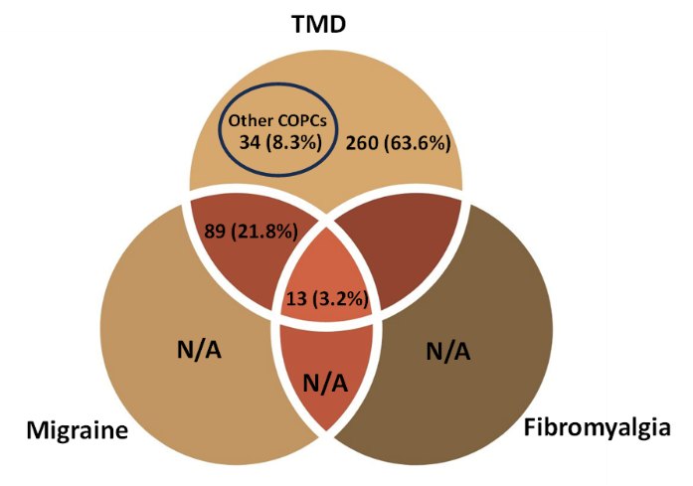
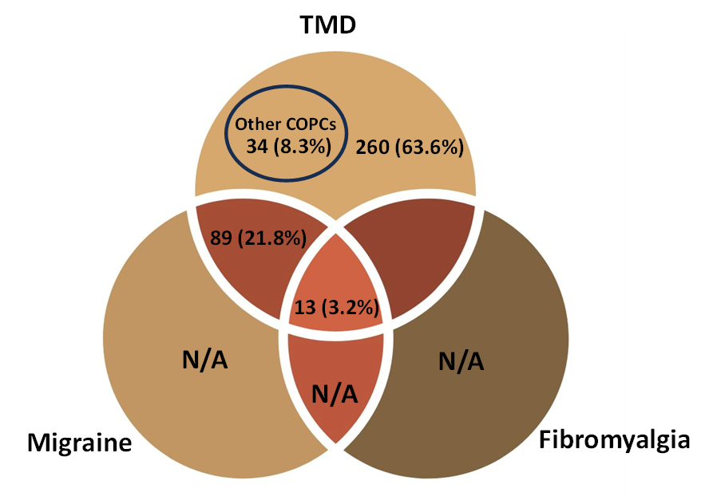
The 1732 medical records of patients referred to orofacial pain clinic over a 7-year period yielded a total number of 409 adult TMD patients (18 years old or older). However, we considered only TMD diagnosed patients without comorbidity and those with comorbid migraine and/or fibromyalgia. A total of 375 patients were included with a mean age of 44.43 years (SD 14.53), of whom 79% were women (Figure 1, Table 1). There were 260 (63.6%) patients with TMD only, 89 (21.8%) with TMD and comorbid migraine (TMD MG), 13 (3.2%) with TMD and comorbid fibromyalgia (TMD FM), and 13 (3.2%) with all three conditions: TMD, migraine, and fibromyalgia (TMD MG FM) (Figure 1). Myalgia-related TMD was the most prevalent classification (53%) among all TMD population (Table 1). Most of TMD patients, 72%, with comorbid migraine from the combination of the TMD MG and the TMD MG FM groups (n=102) reported having chronic migraine with migraine pain distribution in the V1 region (61%) and the remaining experienced migraine pain in facial area, V2 and/or V3 (Table 2). Additionally, myalgia-TMD remains the most frequent subtype among them with the prevalence of 67% (Table 2).

Figure 1. Number of TMD patients with comorbid migraine and fibromyalgia.
TMD = Temporomandibular disorders; COPCs= Chronic Overlapping Pain Conditions

Table 1. Demographic characteristics of the study population
Characteristics | TMD – only  (N=260) | TMD with migraine  (N=89) | TMD with fibromyalgia  (N=13) | TMD with MG + FM  (N=13) | Total  (N=375) | P value
Age (Mean ±SD) | 45.11 ± 15.47 | 41.78 ± 12.41 | 47.15 ± 8.40 | 46..23 ± 11.83 | 44.43 ± 14.53 | 0.241
Female, n (%)  Male, n (%) | 198 (76.2)  62 (28.3) | 75 (84.3)  14 (15.7) | 13 (100)  0 | 12 (92.3)  1 (7.7) | 298 (79.5)  77 (20.5) | 0.053
TMD subtypes, n (%)  Painful TMD; Myalgia  Painful TMD; Arthralgia  Nonpainful TMD  Mixed TMD | 124 (47.7)  14 (5.4)  68 (26.2)  54 (20.8) | 60 (67.4)  7 (7.9)  5 (5.6)  17 (19.1) | 7 (53.8)  1 (7.7)  2 (15.4)  3 (23.1) | 8 (61.5)  3 (23.1)  0  2(15.4) | 199 (53.1)  25 (6.7)  75 (20.0)  76 (20.3)

Table 2. Prevalence of TMD patients with migraine comorbidity (n = 102, TMD + MG and TMD + MG + FMS)

TMD subtypes | Migraine Chronicity |  | Migraine Distribution |  |  |  |  |  | Total N (%)
 | Episodic | Chronic | V1 only | V2 only | V3 only | V1 + V2 | V1 + V2  + V3 | V2+V3
Painful muscle TMD | 17 | 51 | 34 | 5 | 1 | 21 | 4 | 3 | Painful muscle TMD + MG = 68 (66.75)
Painful joint TMD | 4 | 6 | 8 | 0 | 0 | 1 | 1 | 0 | Painful joint TMD + MG = 10 (9.8)
Joint Dysfunction | 3 | 2 | 4 | 0 | 0 | 1 | 0 | 0 | Dysfunctional TMD + MG = 5 (4.9)
Mixed TMD | 4 | 15 | 16 | 1 | 0 | 2 | 0 | 0 | Mixed TMD + MG = 19 (18.6)
Total N (%) | 28 (27.5) | 74 (72.5) | 62 (60.8) | 6 (5.9) | 1 (1) | 25 (24.5) | 5 (4.9) | 3 (2.9) | TMG + MG = 102 (100)

Pain duration
The results obtained from the study showed that in individuals with three concurrent conditions, TMD MG FM, experienced the longest duration of TMD pain, lasting approximately 91 months. This duration was significantly longer compared to the TMD-only and TMD MG groups, as indicated in Table 3 and Figure 2a. In contrast, patients with TMD alone reported the shortest duration of pain, averaging around 43 months, while those in the TMD MG and TMD FM group had a mean duration of about 54 and 51 months, respectively (Table 3). Furthermore, the TMD MG group exhibited a longer period of TMD pain compared to the individuals with TMD alone (p=0.005). Additionally, when the study population was categorised based on the number of comorbidities, it was observed that patients with all three pain conditions had significantly longer pain duration than TMD individuals with one comorbidity (p=0.034) or no comorbidities (p<0.001) (Figure 3a).

Pain intensity and Pain related function.

the BPI pain intensity rating questionnaire was used to assess the severity of pain experienced by participants. Notably, the TMD MG FM group displayed the highest mean scores for the most intense pain (7.5), average pain (6.0), and the least severe pain (5.50) (Table 3, Figure 2). These findings were only statistically significant compared to the TMD-only group. Additionally, the TMD FM group reported significantly higher mean pain scores across all measures compared to the TMD only group, as demonstrated in Figure 1b-d. A similar pattern was observed between the TMD MG and TMD only groups, except for the least intense pain category (Figure 2e). Consequently, when the participants were divided based on the number of comorbidities, it was found that patients with one additional pain condition rated higher all pain scores across compared to those with TMD alone. However, there was no significant difference in pain scores between individuals with one comorbidity and those with two comorbidities, as indicated in Table 4 and Figure 3b-e.

According to the pain interference score, it was observed that TMD patients with two concurrent conditions experienced the greatest degree of pain interference, with a mean score of 6.64. This score was significantly higher compared to the TMD only group (p=0.001), as illustrated in Figure 2f. The statistical difference was as well observed between TMD MG and TMD only group (p=0.13). Moreover, when the participants were categorised based on the number of comorbid conditions, a significant difference in the mean scores was found between patients with one comorbidity and those with two comorbidities (Figure 3f).

The assessment of pain disability using the Grade Chronic Pain Scale showed a significant difference (p< 0.001) among the four groups (Table 4). Among the TMD only patients, the majority (42%) exhibited low intensity of pain and low disability levels. Conversely, the largest proportion of individuals in the TMD MG group and the TMD MG FM group experienced high disability and severe functional limitation, accounting for 42% and 63% of their respective groups. Furthermore, most of TMD FM patients (44%) demonstrated high disability and moderate functional limitation.

Table 3. Descriptive outcomes for pain and psychological variables among populations categorised by type of
comorbidities
Parameters | TMD – only  (N=260) | TMD with migraine  (N=89) | TMD with fibromyalgia  (N=13) | TMD with MG + FM  (N=13) | P value
Pain duration in months (n responders, %)  Mean ±SD | (187, 71.9)  42.82 ± 54.78 | (72, 80.9)  54.11 ± 50.14 | (10, 76.9)  51.00 ± 55.80 | (12, 92.3)  91.00 ± 62.35 | <0.018
Pain severity; (n responders, %)  Worst pain; 0-10 (Mean ±SD)  Lowest pain; 0-10 (Mean ±SD)  Average pain; 0-10 (Mean ±SD)  Now Pain; 0-10 (Mean ±SD) | (115, 44.2)  4.72 ± 2.95  2.86 ± 2.76  3.90 ± 2.61  3.07 ± 2.60 | (55, 61.8)  6.71 ± 2.53  3.93 ± 2.83  5.24 ± 2.49  4.76 ± 2.89 | (9, 69.2)  7.00 ± 1.32  4.67 ± 1.32  5.89 ± 0.78  5.89 ± 1.45 | (8, 61.5)  7.5 ± 1.4  5.50 ± 2.20  6.0 ± 1.31  5.0 ± 1.31 | <0.001  0.005  <0.001  < 0.001
Pain interference; 0-10 (n responders, %)  Mean ±SD | (115, 44.2)  3.43 ± 2.58 | (55, 61.8)  4.76 ± 2.59 | (9, 69.2)  4.77 ± 1.84 | (8, 61.5)  6.64 ± 1.51 | <0.001
Grade Chronic Pain Scale (n responders, %)  Grade 0 No pain in the last 6 months  Grade I Low intensity & Low disability  Grade II High intensity & Low disability  Grade III High disability & Moderate limiting  Grade IV High disability & Severe limiting | (114, 43.8)  6 (5.3)  48 (42.1)  38 (33.3)  10 (8.8)  12 (10.5) | (53, 59.6)  1 (1.9)  13 (24.5)  10 (18.9)  7 (13.2)  22 (41.5) | (9, 69.2)  0  2 (22.2)  2 (22.2)  4 (44.4)  1 (11.1) | (8, 61.5)  0  0  1 (12.5)  2 (25.5)  5 (62.5) | <0.001
Anxiety; GAD-7 (n responders, %)  Total Score (Mean ± SD)  None (Negative/0-4)  Mild (5-9)  Moderate (10-14)  Severe (15-21) | (174, 66.9)  3.63 ± 5.60  134 (77.0)  12 (6.9)  14 (8.0)  14 (8.0) | (69, 77.5)  6.87 ± 7.54  41 (59.4)  2 (2.9)  11 (15.9)  15 (21.7) | (9, 69.2)  8.00 ± 3.16  1 (11.1)  6 (66.7)  2 (22.2)  0 | (12, 92.3)  8.41 ± 7.38  5 (41.7)  1 (8.3)  3 (25.0)  3 (25.0) | < 0.001  < 0.001
Depression; PHQ-9 (n responders, %)  Total Score (Mean ± SD)  None (Negative/0-4)  Mild (5-9)  Moderate (10-14)  Moderate – Severe (15-19)  Severe (≥20) | (167, 64.2)  3.00 ± 6.19  140 (83.8)  5 (3.0)  8 (4.8)  7 (4.2)  7 (4.2) | (67, 75.3)  6.24 ± 8.15  44 (65.7)  1 (1.5)  7 (10.4)  9 (13.4)  6 (9.0) | (9, 69.2)  5.78 ± 3.60  3 (33.3)  3 (33.3)  2 (22.2)  1 (11.1)  0 | (12, 92.3)  9.08 ± 9.08  6 (50.0)  0  2 (16.7)  1(8.3)  3 (25.0) | < 0.001  < 0.001
QoL (n responders, %)  Total Score; 0-25 (Mean ± SD)  Mobility (0-5)  Self – care (0-5)  Usual activities (0-5)  Pain/discomfort (0-5)  Anxiety/depression (0-5)  Health state (score 0-100, worst to best health) | (119, 45.8)  6.75 ± 3.83  1.28 ± 0.64  1.18 ± 0.58  1.41 ± 0.78  2.29 ± 1.15  1.98 ± 1.06  71.29 ± 21.75 | (58, 65.2)  7.02 ± 4.86  1.64 ± 0.97  1.57 ± 0.90  1.90 ± 0.15  2.91 ± 1.11  2.71 ± 1.14  59.91 ± 24.09 | (10, 76.9)  14.20 ± 3.19  2.30 ± 0.95  2.30 ± 0.95  2.80 ± 1.48  3.60 ± 1.17  3.20 ± 1.03  33.40 ± 13.87 | (8, 61.5)  13.12±6.03  2.37±1.30  2.37±1.41  3.12±1.45  3.63±0.92  2.36±1.03  51.12±19.47 | < 0.001  <0.001  < 0.001  < 0.001  < 0.001  <0.001  < 0.001

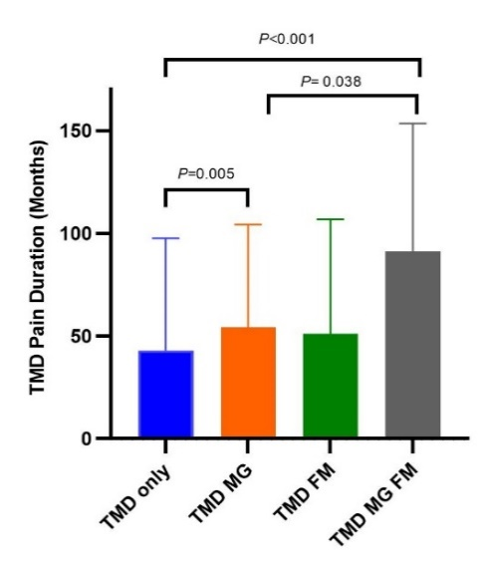
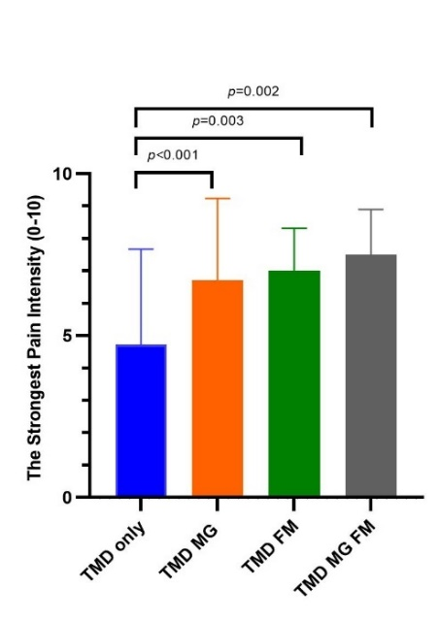
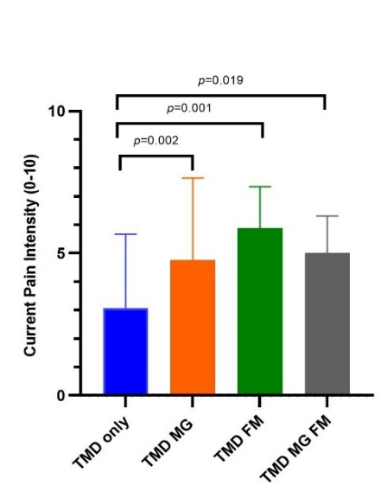
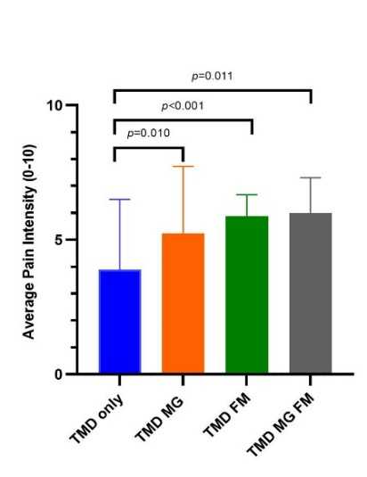
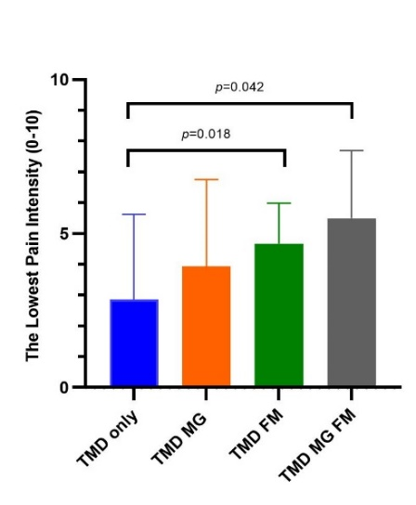
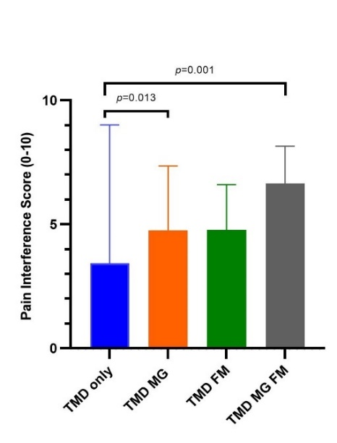
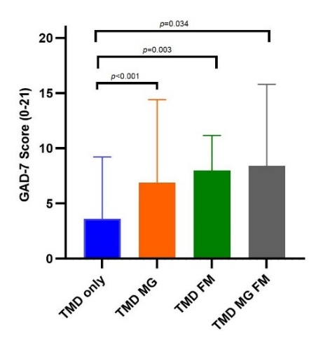
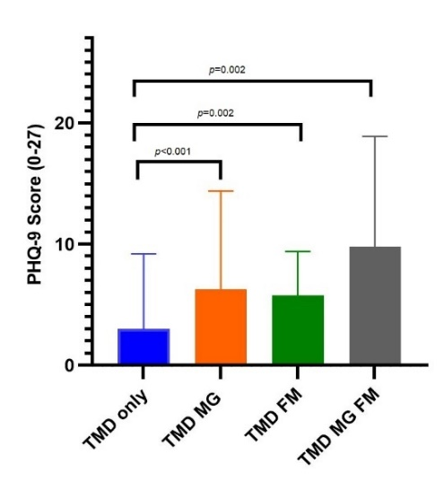
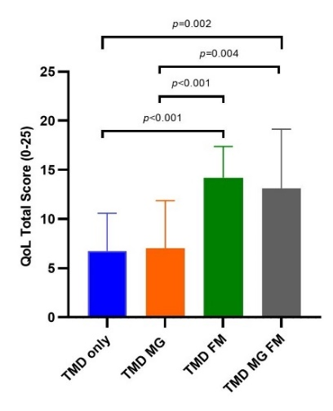
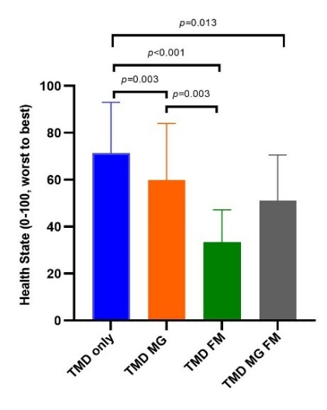
a)
c)
b)
d)
e)
f)
g)
h)
i)
j)

Figure 2. Comparison of the mean±SD value of each pain and psychological variables among four groups.
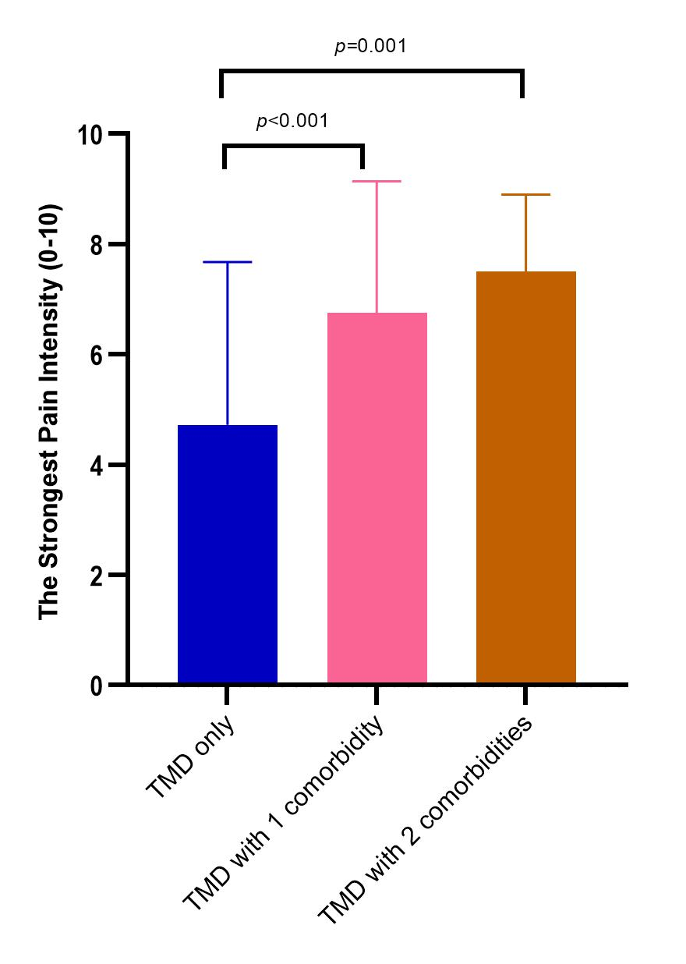
a) Duration of TMD pain in months. b) Current pain ion the clinical visit. c) The strongest pain intensity. d) Average pain intensity. e) The lowest pain intensity f) Pain interference score. g) Generalized anxiety disorder-7 (GAD-7). h) Patient health questionnaire-9 (PHQ-9). i) Quality of life (QoL) score (0-25); 0 indicates on problem of functions or no symptoms and 25 indicates unable to functions or extreme symptoms. j) Overall health state, 0 indicates the worst health and 100 indicates the best health. Note. P -value is shown with significant difference between group when p < 0.05. TMD: temporomandibular disorders; TMD MG: TMD intensity with comorbid migraine; TMD FM; TMD with comorbid fibromyalgia; TMD MG FM: TMD with comorbid migraine and fibromyalgia
Table 4. Descriptive outcomes for pain and psychological variables among populations categorised by number of
comorbidities
Parameters | TMD – only  (No comorbidity)  (N=260) | TMD with 1 comorbidity  (N=102) | TMD with 2 comorbidities  (N=13) | P value
Pain duration in months (n responders, %)  Mean ±SD | (187, 71.9)  42.82 ± 54.78 | (82, 80.4)  53.73 ± 50.55 | (12, 92.3)  91.00 ± 62.35 | < 0.001
Pain severity; (n responders, %)  Worst pain; 0-10 (Mean ±SD)  Lowest pain; 0-10 (Mean ±SD)  Average pain; 0-10 (Mean ±SD)  Now Pain; 0-10 (Mean ±SD) | (115, 44.2)  4.72 ± 2.95  2.86 ± 2.76  3.90 ± 2.61  3.07 ± 2.60 | (64,62.8)  6.75 ± 2.39  4.03 ± 2.67  5.33 ± 2.33  4.92 ± 2.75 | (8, 61.5)  7.5 ± 1.4  5.50 ± 2.20  6.0 ± 1.31  5.0 ± 1.31 | < 0.001  0.002  < 0.001  < 0.001
Pain interference; 0-10 (n responders, %)  Mean ±SD | (115, 44.2)  3.43 ± 2.58 | (64, 62.8)  4.76 ± 2.49 | (8, 61.5)  6.64 ± 1.51 | < 0.001
Grade Chronic Pain Scale (n responders, %)  Grade 0 No pain in the last 6 months  Grade I Low intensity & Low disability  Grade II High intensity & Low disability  Grade III High disability & Moderate limiting  Grade IV High disability & Severe limiting | (114, 43.8)  6 (5.3)  48 (42.1)  38 (33.3)  10 (8.8)  12 (10.5) | (62, 60.8)  1 (1.6)  15 (24.2)  12 (19.4)  11 (17.7)  23 (37.1) | (8, 61.5)  0  0  1 (12.5)  2 (25.5)  5 (62.5) | < 0.001
Anxiety; GAD-7 (n responders, %)  Total Score (Mean ± SD)  None (Negative/0-4)  Mild (5-9)  Moderate (10-14)  Severe (15-21) | (174, 66.9)  3.63 ± 5.60  134 (77.0)  12 (6.9)  14 (8.0)  14 (8.0) | (78, 76.5)  7.00 ± 7.17  42 (53.8)  8 (10.3)  13 (16.7)  15 (19.2) | (12, 92.3)  8.41 ± 7.38  5 (41.7)  1 (8.3)  3 (25.0)  3 (25.0) | < 0.001  0.004
Depression; PHQ-9 (n responders, %)  Total Score (Mean ± SD)  None (Negative/0-4)  Mild (5-9)  Moderate (10-14)  Moderate – Severe (15-19)  Severe (≥20) | (167, 64.2)  3.00 ± 6.19  140 (83.8)  5 (3.0)  8 (4.8)  7 (4.2)  7 (4.2) | (76, 74.5)  6.18 ± 7.74  47 (61.8)  4 (5.3)  9 (11.8)  10 (13.2)  6 (7.9) | (12, 92.3)  9.08 ± 9.08  6 (50)  0  2 (16.7)  1(8.3)  3 (25.0) | < 0.001  0.002
Impact of pain on quality of life; EQ5D (n responders, %)  Total Score; 0-25 (Mean ± SD)  Mobility (0-5, no problem to unable)  Self – care (0-5, no problem to unable)  Usual activities (0-5, no problem to unable)  Pain/discomfort (0-5, no pain to extreme pain)  Anxiety/depression (0-5, no symptoms to extreme symptoms)  Overall health state (score 0-100, worst to best health) | (119, 45.8)  6.75 ± 3.83  1.28 ± 0.64  1.18 ± 0.58  1.41 ± 0.78  2.29 ± 1.15  1.98 ± 1.06  71.29 ± 21.75 | (68, 66.7)  8.07 ± 5.30  1.73 ± 0.99  1.68 ± 0.94  2.03 ± 1.22  3.01 ± 1.14  2.78 ± 1.13  56.01 ± 24.68 | (8, 61.5)  13.12±6.03  2.37±1.30  2.37±1.41  3.12±1.45  3.63±0.92  2.36±1.03  51.12±19.47 | 0.005  < 0.001  < 0.001  < 0.001  < 0.001  < 0.001  < 0.001

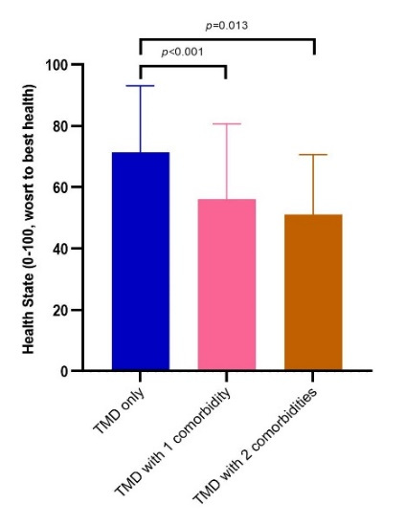
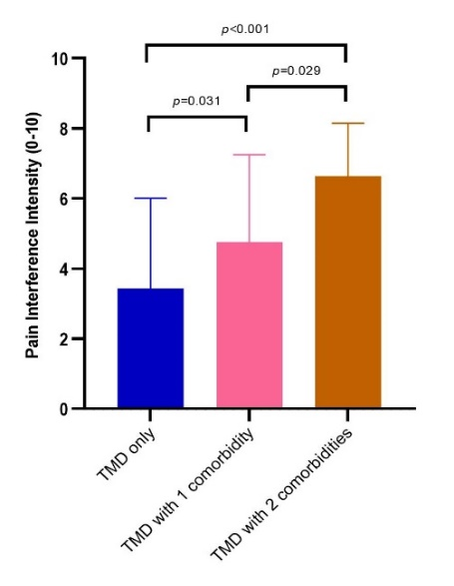
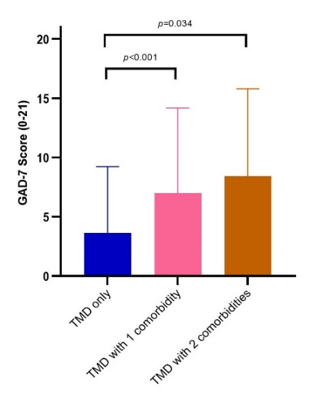
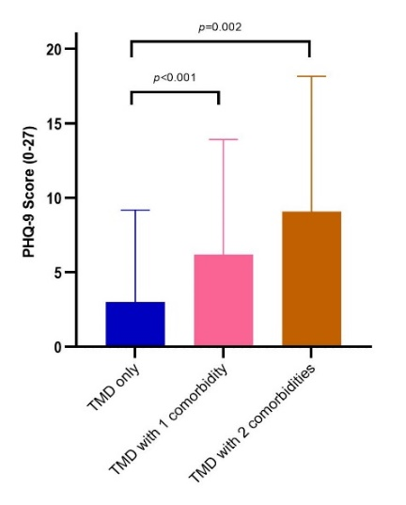
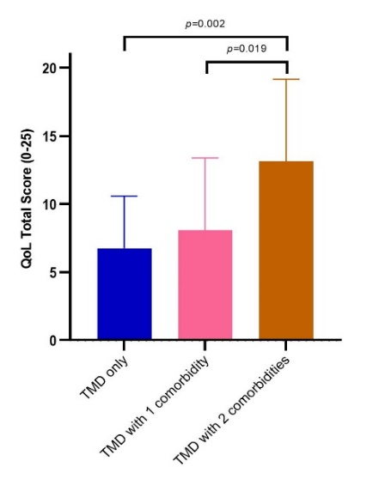
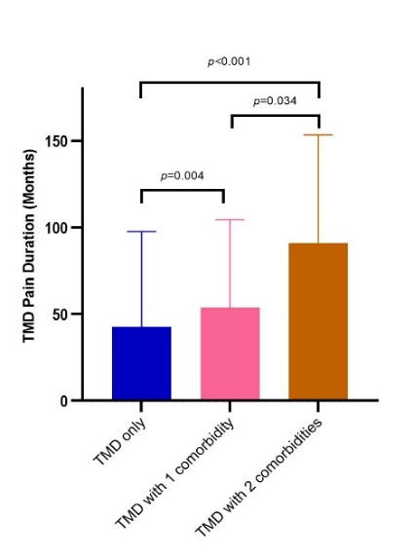
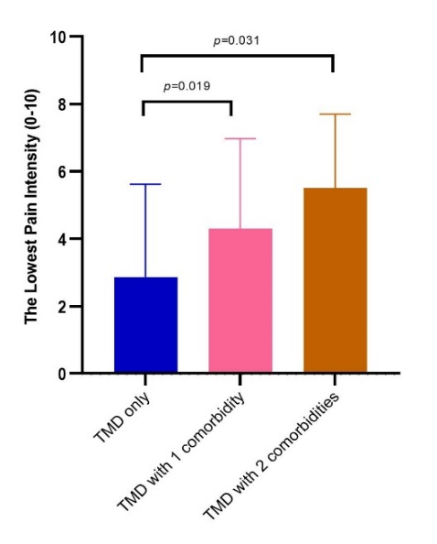
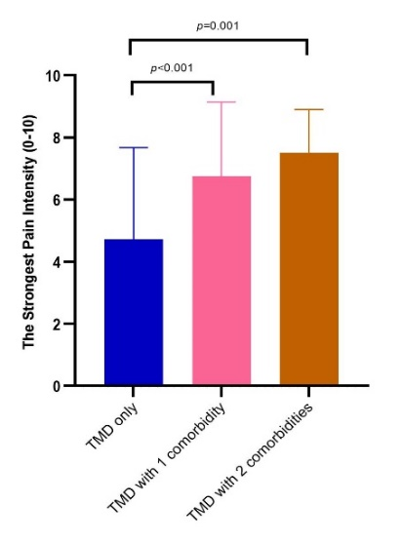
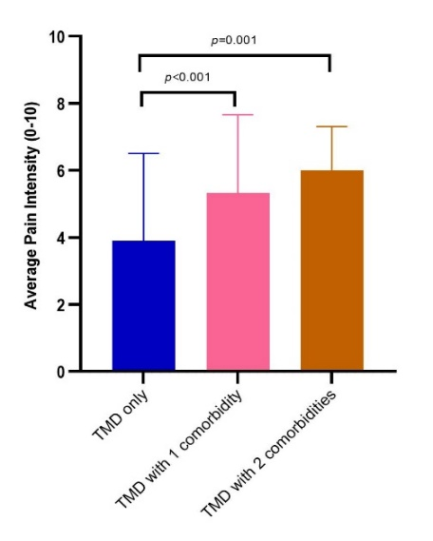
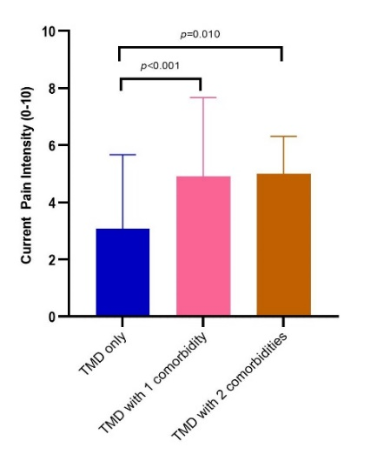
j)
f)
g)
h)
i)
e)
c)
d)
b)
a)
f)
j)

Figure 3. Comparison of the mean±SD value of each pain and psychological variables among three groups.
a) Duration of TMD pain in months. b) Current pain ion the clinical visit. c) The strongest pain intensity. d) Average pain intensity. e) The lowest pain intensity f) Pain interference score. g) Generalized anxiety disorder-7 (GAD-7). h) Patient health questionnaire-9 (PHQ-9). i) Quality of life (QoL) score (0-25); 0 indicates on problem of functions or no symptoms and 25 indicates unable to functions or extreme symptoms. j) Overall health state, 0 indicates the worst health and 100 indicates the best health. Note. P -value is shown with significant difference between group when p < 0.05. TMD: temporomandibular disorders; TMD with one comorbidity (either migraine or fibromyalgia); TMD with two comorbidities which are migraine and fibromyalgia.

Table 5. Result of linear regression between each variable and number of comorbidities
Pain and Psychological measures | Linear association |  |  |  | Linear association  (Adjusted for gender and age)
 | B | 95%CI | β | p-value | B | 95%CI | β | p-value
TMD Pain duration | 0.00 | 0.20, 0.38 | 0.17 | 0.004 | 0.00 | 0.38, 0.99 | 0.17 | 0.005
Strongest pain intensity | 0.07 | 0.04, 0.10 | 0.35 | <0.001 | 0.07 | 0.04, 0.10 | 0.35 | <0.001
Average pain intensity | 0.06 | 0.03, 0.10 | 0.28 | <0.001 | 0.06 | 0.03, 0.10 | 0.28 | <0.001
Current pain intensity | 0.07 | 0.04, 0.10 | 0.31 | <0.001 | 0.07 | 0.04, 0.10 | 0.31 | <0.001
Lowest pain intensity | 0.05 | 0.02, 0.08 | 0.25 | <0.001 | 0.06 | 0.03, 0.09 | 0.27 | <0.001
Pain interference Score | 0.07 | 0.04, 0.10 | 0.32 | <0.001 | 0.07 | 0.04, 0.10 | 0.30 | <0.001
GAD-7 | 0.02 | 0.01, 0.03 | 0.26 | <0.001 | 0.02 | 0.01, 0.03 | 0.25 | <0.001
PHQ-9 | 0.02 | 0.01, 0.03 | 0.26 | <0.001 | 0.02 | 0.01, 0.03 | 0.25 | <0.001
QoL Total Score | 0.03 | 0.01, 0.05 | 0.25 | <0.001 | 0.03 | 0.01, 0.05 | 0.25 | <0.001
Health Status | -0.01 | -0.01, -0.00 | -0.32 | <0.001 | -0.01 | -0.01, -0.00 | -0.32 | <0.001
GAD-7: generalized anxiety disorder-7; PHQ-9: patient health questionnaire-9; QoL: quality of life.
B: unstandardized coefficient; CI: confident interval; β: standardized coefficient.

Anxiety
In the study, anxiety was assessed and classified into different severity levels. The percentages of the study population testing positive for mild to severe anxiety symptoms in each group were 23.0%, 40.6%, 88.9%, and 58.3% in the TMD-only, TMD MG, TMD FM and TMD MG FM groups, respectively. The TMD MG FM group exhibited the highest levels of anxiety among the entire study population, with a mean score of 8.41, as presented in Table 3 and Figure 2g. TMD patients with migraine had a mean anxiety score of 6.87, while those with fibromyalgia had a mean anxiety score of 8.0. In contrast, patients with TMD-only patients had the lowest mean anxiety score of 3.63 (Figure 2g). Moreover, TMD patients with either migraine or fibromyalgia reported significantly higher mean anxiety scores than patients with TMD alone (migraine, p < 0.001; fibromyalgia, p=0.003; Figure 2g). However, when the participants were grouped by the number of pain conditions, no significant difference was found between TMD patients with one comorbidity and those with two comorbidities in terms of anxiety scores (Figure 3g).
Depression
A similar trend was observed concerning depression symptoms, with the proportions of the study population testing positive for mild to severe depression being 16.7%, 34.3%, 66.7%, and 50.0% in the TMD-only, TMD MG, TMD FM, and TMD MG FM groups, respectively. The TMD MG FM group rated the highest depression scores, with a mean of 9.08 (Table 3). These scores were significantly higher than those of the TMD-only group (p=0.002), as depicted in Figure 2h. The TMD MG group reported a mean depression score of 6.24, while TMD FM had a mean depression score of 5.78 (Table 3). On the contrary, patients with TMD only had the lowest mean depression score of 3.00. As shown in Figure 2h, patients with either migraine or fibromyalgia demonstrated significantly higher mean anxiety scores than patients with TMD only (migraine, p<0.001; fibromyalgia, p=0.002). When analysing the data based on the number of comorbidities, a statistical difference was observed between TMD MG FM and TMD-only, as well as between the TMD group with one comorbidity and the TMD-only group. No significant difference in depression scores was found between TMD patients with one comorbidity and those with two comorbidities (Figure 3h).

Impact of pain on quality of life and health state
For the domain of the impact of pain on QoL, higher scores indicate a greater impact of pain on patients' lives. Among the study participants, the TMD FM group demonstrated the highest mean pain impact score amounting to 14.20 out of 25, followed by TMD FM MG group, TMD MG group, and TMD only group, as evidenced by the data in Table 3 and Figure 2i. Moreover, a post-hoc test revealed a significant difference in QoL scores between TMD patients with migraine and those with fibromyalgia (p < 0.001) (Figure 2i). Analysis based on the number of comorbidities indicated differences in the impact of pain. Specifically, individuals with TMD who had two pain conditions experienced a significantly greater impact of pain on their QoL compared to those with only one comorbidity (p=0.019) or no comorbidities (p=0.002), as shown in Figure 2i.

When assessing general health state, higher scores indicate better overall health status. The result showed that TMD-only group had the highest mean score of 71.3, followed by the TMG MG group with a score of 59.9, the TMD MG FM group with a score of 51.1, and the TMD FM group with a score of 33.4 (Table 3). Moreover, a significant mean score difference was observed between TMD patients with migraine and those with fibromyalgia (p=0.003), as shown in Figure 2j. Furthermore, when considering the grouping of the study population by the number of pain conditions, it is worth noting that there was a significant difference between the TMD-only group and both the TMD group with one comorbidity (p=0.001) and the TMD group with two comorbidities (p=0.013). However, no significant difference was found between individuals with only one comorbidity and those with two comorbidities (Figure 3j).

Association of pain and psychological measures and number of pain comorbidities
The results of linear regression analyses examining the associations between each variable and the number of comorbidities, with the adjustment for gender and age, are shown in Table 5. Results are reported in terms of regression coefficients (B), 95% confidence intervals (95% CI), standardised regression coefficients (β), and p-values. Regarding pain and psychological measures, there was a significant positive association between the duration of TMD pain and the number of comorbidities (B = 0.00, 95% CI [0.20, 0.38], β = 0.17, p = 0.004). Similarly, all measures of pain intensity, pain interference score, anxiety score, depression score, and QoL score showed significant positive associations with the number of comorbidities with p < 0.001 for all variables. In contrast, health status showed a significant negative association with the number of comorbidities (B = -0.01, 95% CI [-0.01, -0.00], β = -0.32, p < 0.001). However, after adjusting for potential confounders, sex and gender, all variables remained correlated with increasing number of pain conditions.

Discussion
To our knowledge, this is the first study to examine the specific influence of migraine and fibromyalgia on pain duration, intensity, psychological factors and QoL in individuals with TMD. The selection of these comorbidities was based on their prevalence as pain conditions, representing both localised and generalised pain comorbidities, which in this study referred to migraine and fibromyalgia. The current study provides valuable insights into the impact of migraine and fibromyalgia on various clinical outcomes. The results indicated that TMD patients with migraine experienced prolonged pain duration, higher level of current, strongest, and average pain, increased pain interference, greater anxiety and depression and more impairment of health status compared to those with TMD only. While TMD patients with FM reported more pain intensity across all measures, higher level of anxiety and depression, lower QoL and greater impairment of general health compared to those with TMD only. When comparing TMD patients with migraine and those with fibromyalgia, statistical distinctions emerged in the impact of pain on QoL and overall health state. This suggests that the different type of comorbidity, either migraine or fibromyalgia, did not have a significant impact on pain outcomes, anxiety, and depression among TMD patients, while it did show a noticeable influence on the quality of life and overall general health of these individuals. However, it is important to note that the number of subjects with TMD FM in our study was relatively small compared with subjects with TMD only and TMD MG. This smaller sample size may limit the generalisability of our findings and the statistical power of our analyses. Therefore, conducting future studies with a larger population sample may provide additional perspectives and potentially yield more meaningful and robust results.

Moreover, as the number of comorbidities increased, statistically significant variations were observed in the duration of TMD pain and the extent of pain interference. These findings suggested that patients with a higher number of comorbidities experienced prolonged pain duration and a greater extent of pain interference. Furthermore, significant differences were found in pain intensity across all measures, as well as in psychological symptoms (anxiety and depression) and general health when comparing individuals with TMD only to those with a single comorbid condition. On the other hand, TMD patients with two comorbid pain conditions (TMD MG FM) exhibited a more pronounced impact on quality of life compared to patients with only one comorbid condition (TMD MG or FM). Therefore, the concurrence of pain conditions is positively associated with the increase of pain outcomes, psychological distress, QoL and general health of TMD patients. These results support the need for comprehensive and multidisciplinary approaches to address the complex health challenges faced by TMD patients.

The findings of this study revealed that approximately 36% of patients with TMD exhibited at least one painful comorbidity. This proportion was comparatively lower than the figures reported in other cross-sectional studies (62%) ²⁸ and a case-control study (70%) ²⁹. The diminished percentage observed in our study may be attributed to the retrospective study design employed, which possibly resulted in an underestimation of comorbidities. Furthermore, the prevalence rates of migraine and fibromyalgia within the TMD population were determined to be 25% and 6.4%, respectively. These rates were also found to be lower when compared to previous prevalence estimates obtained from systematic analyses, which reported rates of 40% for migraine and 14% for fibromyalgia ⁶. Moreover, among the TMD patients with comorbidities in our study, a majority presented with muscle-related TMD, which is consistent with prior ^{30–32}. This association can potentially be explained by the fact that the majority of TMD patients in our study exhibited painful muscle-related TMD conditions.

The results of our study showed that TMD pain exhibits prolonged duration in patients with multiple comorbidities, and this prolongation is positively correlated with an increasing number of concurrent pain conditions. This similar association was also found in a previous cross-sectional, multi-site study involving 180 TMD patients ²⁸ as well as a longitudinal study between TMD patients who had persistent TMD pain after 5 years to those without pain after 5 years ³³. While our study did not investigate the association between the presence of specific comorbidities, migraine and fibromyalgia, and their impact on clinical outcomes. However, previous investigations have explored the effects of these conditions on TMD. For instance, Velley conducted a study where the presence of fibromyalgia was found to be significantly associated with the persistence of clinically significant TMD ³⁰. Additionally, Dahan reported that the presence of migraine was positively correlated with increased TMD pain intensity and duration ²⁸. Therefore, the underlying mechanisms that contribute to the persistence of pain in TMD patients, particularly those with comorbidities, might be related to mechanism of central sensitisation ^{12,13}.

The intensity of pain and its interference in TMD showed a similar pattern of association with the number of comorbidities. As the number of pain conditions increased, both pain intensity and pain interference became greater. Our study's findings align with previous investigations that also found a positive association between pain intensity and the number of comorbidities in TMD patients, particularly in cases of migraine and chronic fatigue syndrome ²⁸. Another study conducted in the Chinese population, which examined multiple pain sites throughout the body, also discovered a correlation between an increasing number of pain symptoms and greater severity of TMD pain ³⁴. Furthermore, Raphael's study on myofascial TMD patients, with and without fibromyalgia, revealed that TMD patients with a history of fibromyalgia were more likely to experience more pain symptoms and pain interference ³⁵. Similarly, another study in TMD patients reported higher pain intensity among those with comorbid fibromyalgia ³⁰. Based on the collective findings of these studies, it can be inferred that individuals experiencing widespread pain are more likely to have higher levels of TMD pain intensity compared to those with localised pain ^{30,35}. This explanation could potentially account for the slightly elevated TMD pain intensity observed in patients with fibromyalgia (widespread pain) compared to those with migraine (localised pain) in our study, although the difference did not reach statistically significant.

The heightened intensity and prolonged duration of pain observed in TMD patients with migraine and fibromyalgia can be attributed to the phenomenon of pain amplification. These conditions fall under the category of chronic overlapping pain conditions (COPCs) ⁵. Empirical evidence from cross-sectional studies have shown that a significant number of individuals diagnosed with COPCs, including TMD ^{36–38}, fibromyalgia ^{39,40}, and migraine ^{41–43}, exhibit pain amplification. Enhanced pain sensitivity is a common characteristic among patients with COPCs, although its role as a risk factor or consequence of COPCs is still a subject of debate ⁵. Pain amplification, along with processes involved in pain transmission and modulation, plays a crucial role in sustaining COPCs. Patients with COPCs may have heightened pain perception due to dysregulation in peripheral and central systems, resulting in changes in the activity of neuronal and glial cells and central sensitisation ⁵. Therefore, we suggest that the prolonged duration of pain and heightened perception of pain intensity are likely attributable to the involvement of pain amplification and central sensitisation mechanisms.
In this study, we found that patients with migraine and/or fibromyalgia experienced significantly higher levels of anxiety and depression compared to those without these comorbidities. However, the difference between migraine and fibromyalgia in terms of their impact on anxiety and depression was not significant. These results support previous research findings that individuals with these pain conditions, TMD ⁴⁴, fibromyalgia ⁴⁵ and migraine ⁴⁶ often exhibit certain psychological features and report high levels of somatic symptoms. The cumulative effect of having multiple comorbid conditions was also positively associated with both anxiety and depression. This is consistent with previous study that has shown that the presence of multiple pain conditions is linked to more severe psychological symptoms ⁴⁷. Another study reported that TMD, migraine, and fibromyalgia, as well as the number of comorbid pain conditions, were associated with several psychological factors, with somatic symptom burden being the strongest predictor ⁴⁸. However, our study specifically examined the psychological aspects of anxiety and depression in TMD patients, focusing on localised pain (migraine) and the comorbidity of widespread pain (fibromyalgia). It is important to acknowledge that the existing body of research on TMD patients has predominantly focused on phenomena such as catastrophizing and somatization, rather than psychiatric disorders like depression and anxiety ⁶. Although our study did not measure somatic symptoms as prior studies and explored a narrower range of pain conditions, it provides valuable insights into the psychological burden experienced by these patients. Nevertheless, previous literatures have shown the bidirectional relationships between pain and psychological disabilities. For instance, the existence of chronic pain conditions is a risk factor for adverse negative psychological outcomes, such as increased stress, anxiety, and depression ^{49–51}. On the other hand, that psychological symptoms can act as predisposing factors for the development of chronic pain conditions in the future ^{52–54}. Overall, several psychosocial factors, including somatic symptom and distress, negative mood, and environmental stress, independently or in combination, contribute to the risk of developing and maintaining comorbid pain conditions.
Another important aspect to consider is the influence of comorbid conditions on the QoL and general health status of patients diagnosed with TMD. In this study, the EQ5D questionnaire was used to assess several domains, including functional ability, pain or discomfort, and anxiety/depression. The results showed that individuals with multiple comorbidities experienced a greater impact of pain on their QoL and had lower overall health status. Although the statistical difference was only observed between TMD with one comorbidity and those with two comorbidities. Numerous studies have consistently revealed that TMD ^{55–57} and other chronic pain patients ^{58,59} reported lower QoL, with a direct relationship between the two ^{60,61}. Additionally, a systematic review has highlighted the adverse psychological and physical consequences associated with TMD, which ultimately contribute to a reduced QoL ⁶². Hence, in the context of our study, the higher QoL impact scores and greater impairment in overall health in patients with comorbid conditions may be attributed to increased pain intensity and higher levels of anxiety and depression. These findings support the importance of adopting a holistic approach to the treatment of TMD patients with comorbidities, one that takes into consideration the multifaceted aspects of health and well-being.

The present study has some limitations that need to be acknowledged. Firstly, the study population consisted of patients attending a tertiary care clinic in a dental hospital, which may not accurately reflect the prevalence of disease in the general population. Additionally, the retrospective design of the study may have led to an underestimated prevalence of the conditions, and the possibility of missing data could have implications for the results. Another important aspect is the use of self-report questionnaires, which may cause potential biases and affect the accuracy of the responses. However, it should be noted that all questionnaires used in this study were validated for their psychiatric properties. Moreover, several other questionnaires are available that could be employed in future studies to provide a more comprehensive assessment of the relevant factors.
Conclusion
The results of the study shed light on significant impact of migraine and fibromyalgia on various aspects of TMD, including pain duration, intensity, interference, psychological well-being, quality of life, and overall health status. These findings underscore the importance of a comprehensive and integrated approach to the assessment and management of TMD patients, considering the presence of comorbidities and addressing both physical and psychological aspects of the condition. Further research is warranted to elucidate the underlying mechanisms and develop targeted interventions to address the complex needs of individuals with TMD and other pain comorbidities.

Acknowledgments
We are very grateful to the IMPARTS team and the Research Oversight Committee for their invaluable assistance with data collection and permission to use patient outcome data in our analysis. The IMPARTS initiative is funded in part by the SLAM Biomedical Research Centre and receives additional support from the National Institute for Health Research (NIHR) Mental Health Biomedical Research Centre at South London, the Maudsley NHS Foundation Trust, and King's College London. We would also like to express our sincere gratitude to the entire staff of the Orofacial Pain Clinic at Kings Dental Institute for their invaluable support and to all the patients who willingly participated in this research project.

References
1. Gauer RL, Semidey MJ. Diagnosis and treatment of temporomandibular disorders. Am Fam Physician 2015; 91: 378–86.
2. Magnusson T, Egermark I, Carlsson GE. A prospective investigation over two decades on signs and symptoms of temporomandibular disorders and associated variables. A final summary. Acta Odontol Scand 2005; 63: 99–109.
3. Schiffman E, Ohrbach R, Truelove E, et al. Diagnostic Criteria for Temporomandibular Disorders (DC/TMD) for Clinical and Research Applications: Recommendations of the International RDC/TMD Consortium Network * and Orofacial Pain Special Interest Group † HHS Public Access. 2014.
4. Slade GD, Bair E, Greenspan JD, et al. Signs and Symptoms of First-Onset TMD and Sociodemographic Predictors of Its Development: The OPPERA Prospective Cohort Study. J Pain 2013; 14: T20-T32.e3.
5. Maixner W, Fillingim RB, Williams DA, et al. Overlapping Chronic Pain Conditions: Implications for Diagnosis and Classification. J Pain 2016; 17: T93–T107.
6. Kleykamp BA, Ferguson MC, McNicol E, et al. The prevalence of comorbid chronic pain conditions among patients with temporomandibular disorders: A systematic review. J Am Dent Assoc 2022; 153: 241-250.e10.
7. Hoffmann RG, Kotchen JM, Kotchen TA, et al. Temporomandibular Disorders and Associated Clinical Comorbidities. Clin J Pain 2011; 27: 268–274.
8. Costa YM, Conti PCR, de Faria FAC, et al. Temporomandibular disorders and painful comorbidities: clinical association and underlying mechanisms. Oral Surg Oral Med Oral Pathol Oral Radiol 2017; 123: 288–297.
9. Thomas DC, Khan J, Manfredini D, et al. Temporomandibular Joint Disorder Comorbidities. Dent Clin North Am 2023; 67: 379–392.
10. Franco AL, Gonçalves DAG, Castanharo SM, et al. Migraine is the most prevalent primary headache in individuals with temporomandibular disorders. J Orofac Pain 2010; 24: 287–92.
11. Gonçalves DAG, Camparis CM, Franco AL, et al. How to Investigate and Treat: Migraine in Patients with Temporomandibular Disorders. Curr Pain Headache Rep 2012; 16: 359–364.
12. Grossi DB, Lipton RB, Bigal ME. Temporomandibular disorders and migraine chronification. Curr Pain Headache Rep 2009; 13: 314–318.
13. Woolf CJ. Central sensitization: Implications for the diagnosis and treatment of pain. Pain 2011; 152: S2–S15.
14. Wolfe F, Clauw DJ, Fitzcharles M-A, et al. 2016 Revisions to the 2010/2011 fibromyalgia diagnostic criteria. Semin Arthritis Rheum 2016; 46: 319–329.
15. Fraga BP, Santos EB, Farias Neto JP, et al. Signs and symptoms of temporomandibular dysfunction in fibromyalgic patients. J Craniofac Surg 2012; 23: 615–8.
16. da Silva LA, Kazyiama HH, de Siqueira JTT, et al. High prevalence of orofacial complaints in patients with fibromyalgia: a case-control study. Oral Surg Oral Med Oral Pathol Oral Radiol 2012; 114: e29-34.
17. Salvetti G, Manfredini D, Bazzichi L, et al. Clinical features of the stomatognathic involvement in fibromyalgia syndrome: a comparison with temporomandibular disorders patients. Cranio 2007; 25: 127–33.
18. Yunus MB. The Prevalence of Fibromyalgia in Other Chronic Pain Conditions. Pain Res Treat 2012; 2012: 1–8.
19. Lorduy KM, Liegey-Dougall A, Haggard R, et al. The Prevalence of Comorbid Symptoms of Central Sensitization Syndrome Among Three Different Groups of Temporomandibular Disorder Patients. Pain Pract 2013; 13: 604–613.
20. Harper DE, Sayre K, Schrepf A, et al. Impact of Fibromyalgia Phenotype in Temporomandibular Disorders. Pain Med 2021; 22: 2050–2056.
21. The International Classification of Headache Disorders, 3rd edition (beta version). Cephalalgia 2013; 33: 629–808.
22. Lee JYK, Chen HI, Urban C, et al. Development of and psychometric testing for the Brief Pain Inventory–Facial in patients with facial pain syndromes. J Neurosurg 2010; 113: 516–523.
23. Poquet N, Lin C. The Brief Pain Inventory (BPI). J Physiother 2016; 62: 52.
24. Von Korff M, Ormel J, Keefe FJ, et al. Grading the severity of chronic pain. Pain 1992; 50: 133–149.
25. Kroenke K, Spitzer RL, Williams JB. The PHQ-9: validity of a brief depression severity measure. J Gen Intern Med 2001; 16: 606–13.
26. Spitzer RL, Kroenke K, Williams JBW, et al. A Brief Measure for Assessing Generalized Anxiety Disorder. Arch Intern Med 2006; 166: 1092.
27. Rabin R, Charro F de. EQ-SD: a measure of health status from the EuroQol Group. Ann Med 2001; 33: 337–343.
28. Dahan H, Shir Y, Velly A, et al. Specific and number of comorbidities are associated with increased levels of temporomandibular pain intensity and duration. J Headache Pain 2015; 16: 47.
29. Ohrbach R, Fillingim RB, Mulkey F, et al. Clinical Findings and Pain Symptoms as Potential Risk Factors for Chronic TMD: Descriptive Data and Empirically Identified Domains from the OPPERA Case-Control Study. J Pain 2011; 12: T27–T45.
30. Velly AM, Look JO, Schiffman E, et al. The Effect of Fibromyalgia and Widespread Pain on the Clinically Significant Temporomandibular Muscle and Joint Pain Disorders—A Prospective 18-Month Cohort Study. J Pain 2010; 11: 1155–1164.
31. Velly AM, Fricton J. The Impact of Comorbid Conditions on Treatment of Temporomandibular Disorders. J Am Dent Assoc 2011; 142: 170–172.
32. Velly AM, Gornitsky M, Philippe P. Contributing factors to chronic myofascial pain: a case–control study. Pain 2003; 104: 491–499.
33. Rammelsberg P, LeResche L, Dworkin S, et al. Longitudinal outcome of temporomandibular disorders: a 5-year epidemiologic study of muscle disorders defined by research diagnostic criteria for temporomandibular disorders. J Orofac Pain 2003; 17: 9–20.
34. Yap AUJ, Chua EK, Dworkin SF, et al. Multiple pains and psychosocial functioning/psychologic distress in TMD patients. Int J Prosthodont 2002; 15: 461–6.
35. Raphael KG, Marbach JJ, Klausner J. Myofascial face pain. Clinical characteristics of those with regional vs. widespread pain. J Am Dent Assoc 2000; 131: 161–71.
36. Sarlani E, Greenspan JD. Evidence for generalized hyperalgesia in temporomandibular disorders patients. Pain 2003; 102: 221–226.
37. Maixer W. Myogenous temporomandibular disorder: A persistent pain condition associated with hyperalgesia and enhanced temporal summation of pain. In: Progress in pain research and management. 2004, pp. 373–386.
38. Maixner W, Fillingim R, Booker D, et al. Sensitivity of patients with painful temporomandibular disorders to experimentally evoked pain. Pain 1995; 63: 341–351.
39. Staud R. New evidence for central sensitization in patients with fibromyalgia. Curr Rheumatol Rep 2004; 6: 259–259.
40. Bradley LA, McKendree-Smith NL. Central nervous system mechanisms of pain in fibromyalgia and other musculoskeletal disorders: behavioral and psychologic treatment approaches. Curr Opin Rheumatol 2002; 14: 45–51.
41. Kitaj MB, Klink M. Pain Thresholds in Daily Transformed Migraine Versus Episodic Migraine Headache Patients. Headache J Head Face Pain 2005; 45: 992–998.
42. Lipton RB, Bigal ME, Ashina S, et al. Cutaneous allodynia in the migraine population. Ann Neurol 2008; 63: 148–158.
43. Weissman-Fogel I, Sprecher E, Granovsky Y, et al. Repeated noxious stimulation of the skin enhances cutaneous pain perception of migraine patients in-between attacks: clinical evidence for continuous sub-threshold increase in membrane excitability of central trigeminovascular neurons. Pain 2003; 104: 693–700.
44. Fillingim RB, Ohrbach R, Greenspan JD, et al. Potential psychosocial risk factors for chronic TMD: descriptive data and empirically identified domains from the OPPERA case-control study. J pain 2011; 12: T46-60.
45. Schmidt-Wilcke T, Clauw DJ. Fibromyalgia: from pathophysiology to therapy. Nat Rev Rheumatol 2011; 7: 518–27.
46. Grassini S, Nordin S. Comorbidity in Migraine with Functional Somatic Syndromes, Psychiatric Disorders and Inflammatory Diseases: A Matter of Central Sensitization? Behav Med 2017; 43: 91–99.
47. Schrepf A, Williams DA, Gallop R, et al. Sensory sensitivity and symptom severity represent unique dimensions of chronic pain: a MAPP Research Network study. Pain 2018; 159: 2002–2011.
48. Fillingim R, Ohrbach R, Greenspan J, et al. Associations of Psychologic Factors with Multiple Chronic Overlapping Pain Conditions. J Oral Facial Pain Headache 2020; 34: s85–s100.
49. Gerrits MM, van Oppen P, Leone SS, et al. Pain, not chronic disease, is associated with the recurrence of depressive and anxiety disorders. BMC Psychiatry 2014; 14: 187.
50. Bushnell MC, Case LK, Ceko M, et al. Effect of environment on the long-term consequences of chronic pain. Pain 2015; 156: S42–S49.
51. Abdallah CG, Geha P. Chronic Pain and Chronic Stress: Two Sides of the Same Coin? Chronic Stress 2017; 1: 247054701770476.
52. Fillingim RB, Ohrbach R, Greenspan JD, et al. Psychological Factors Associated With Development of TMD: The OPPERA Prospective Cohort Study. J Pain 2013; 14: T75–T90.
53. Mierswa T, Kellmann M. Differences in low back pain occurrence over a 6-month period between four recovery-stress groups. Work 2017; 58: 193–202.
54. Lerman SF, Rudich Z, Brill S, et al. Longitudinal Associations Between Depression, Anxiety, Pain, and Pain-Related Disability in Chronic Pain Patients. Psychosom Med 2015; 77: 333–341.
55. Tjakkes G-HE, Reinders J-J, Tenvergert EM, et al. TMD pain: the effect on health related quality of life and the influence of pain duration. Health Qual Life Outcomes 2010; 8: 46.
56. Moreno B, Maluf S, Marques A, et al. Clinical and quality-of-life assessment among women with temporomandibular disorder. Brazilian J Phys Ther 2009; 13: 210–214.
57. Pereira TC, Brasolotto AG, Conti PC, et al. Temporomandibular disorders, voice and oral quality of life in women. J Appl Oral Sci 2009; 17: 50–56.
58. Hadi MA, McHugh GA, Closs SJ. Impact of Chronic Pain on Patients’ Quality of Life: A Comparative Mixed-Methods Study. J Patient Exp 2019; 6: 133–141.
59. Rapti E, Damigos D, Apostolara P, et al. Patients with chronic pain: evaluating depression and their quality of life in a single center study in Greece. BMC Psychol 2019; 7: 86.
60. Miettinen O, Lahti S, Sipilä K. Psychosocial aspects of temporomandibular disorders and oral health-related quality-of-life. Acta Odontol Scand 2012; 70: 331–336.
61. Blanco-Aguilera A, Blanco-Hungria A, Biedma-Velazquez L, et al. Application of an oral health-related quality of life questionnaire in primary care patients with orofacial pain and temporomandibular disorders. Med Oral Patol Oral y Cir Bucal 2014; e127–e135.
62. Bitiniene D, Zamaliauskiene R, Kubilius R, et al. Quality of life in patients with temporomandibular disorders. A systematic review. Stomatologija 2018; 20: 3–9.

